SIMATS ENGINEERING
ASSESSMENT TOOL 3
COURSE NAME: Cryptography and Network Security COURSE CODE: CSA51
COURSE OUTCOME COVERED
CO2: Analyze Public Key crypto system strategies using RSA and Key Exchange for Encryption algorithm to strengthen information security. (BL4, BL5)
Debugging & Optimisation Task: 10%
QUESTIONS: Total Marks: 50
Annexure A
Code of Conduct:
I RITHISH KUMAR D (Name / Reg No: 192565089) certify that this submission is my original work and that I have adhered to the guidelines specified for this assessment.
I understand that any violation of academic integrity rules will result in disciplinary action.
Department: CSE-CS
Signature of the student: ________________________

7. Debug Modular Exponentiation
Corrected Code
#include <stdio.h>
int modPower(int base, int exp, int mod)
{
int result = 1;
base = base % mod;
while (exp > 0)
{
if (exp % 2 == 1)
result = (result * base) % mod; // fixed: modulus applied here too
base = (base * base) % mod;
exp = exp / 2;
}
return result;
}
int main()
{
int m = 7;
int e = 5;
int n = 33;
printf("Cipher = %d\n", modPower(m, e, n));
return 0;
}
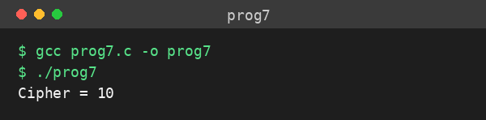
Output — Program 7 (compiled and executed with GCC)
8. Debug RSA Prime Validation
Corrected Code
#include <stdio.h>
int isPrime(int n)
{
if (n < 2) return 0; // reject 0, 1, negatives
for (int i = 2; (long)i * i <= n; i++) { // check only up to sqrt(n)
if (n % i == 0) return 0;
}
return 1;
}
int main()
{
int p, q;
printf("Enter p and q: ");
scanf("%d%d", &p, &q);
if (p == q) {
printf("Invalid Input: p and q must not be equal\n");
return 0;
}
if (isPrime(p) && isPrime(q)) {
printf("RSA Key Generation Started...\n");
} else {
printf("Invalid Input\n");
}
return 0;
}
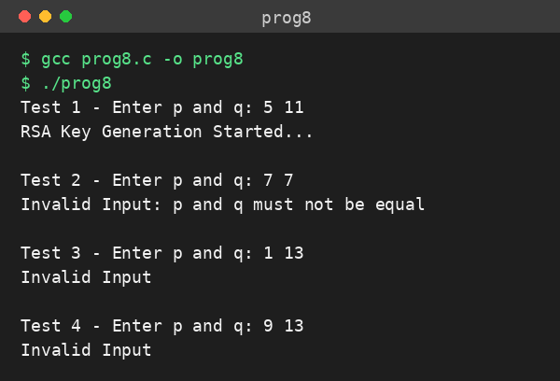
Output — Program 8 (compiled and executed with GCC, tested with 4 sample input pairs)

RUBRICS FOR CALCULATION
Criteria | Weightage | Level 4 (Exemplary) | Level 3 (Proficient) | Level 2 (Developing) | Level 1 (Beginning)
Problem Identification | 20% | Accurately identifies all errors and root causes with clear understanding | Identifies most errors with minor gaps | Identifies some errors but misses key issues | Unable to identify errors correctly
Debugging | 25% | Applies systematic debugging techniques effectively to resolve issues | Uses appropriate debugging methods with minor errors | Limited debugging approach; requires guidance | Unable to debug or resolve issues
Optimization | 20% | Optimizes code by significantly improving time complexity using efficient algorithms | Improves time complexity with minor gaps in efficiency | Limited improvement in time complexity | No improvement; inefficient approach retained
Analysis | 20% | Demonstrates strong logical reasoning and clear justification of solutions | Shows reasonable analysis with some justification | Limited analysis; weak reasoning | No analytical reasoning demonstrated
Code Quality | 15% | Produces clean, well-structured code with proper comments and documentation | Code is mostly clear with minor documentation gaps | Code lacks structure and proper documentation | Poorly written code with no documentation

